1. Process: System Setup Process
2. Purpose: Configure various parameters for the system to work properly
3. Screens in this process

|  |  |  |
| --- | --- | --- |
| **Screen Name** | **Purpose** | **Access By User Role** |
| Maintain Reference Data | To view/edit reference data (items in the various dropdowns) | IUMSADMIN (login id: sys) |
| Maintain University | To edit university details | IUMSADMIN (login id: sys) |
| Maintain Academic Year | To define & edit academic year | IUMSADMIN (login id: sys) |
| Maintain Programs | To maintain programs | IUMSADMIN (login id: sys) |
| Maintain Courses | To maintain courses | IUMSADMIN (login id: sys) |
| Maintain Program Courses | To allocate courses to programs | IUMSADMIN (login id: sys) |
| Maintain College | To maintain colleges | IUMSADMIN (login id: sys) |
| Maintain College Groups | To maintain groups of colleges for sharing faculty and hostel facility | IUMSADMIN (login id: sys) |
| Maintain Fees | To Maintain fee structure | IUMSADMIN (login id: sys) |
| Maintain Academic Calendar | To maintain academic calendar | IUMSADMIN (login id: sys) |
| Maintain Group-Users | To maintain user groups | IUMSADMIN (login id: sys) |

1. Screens

4.1 Login

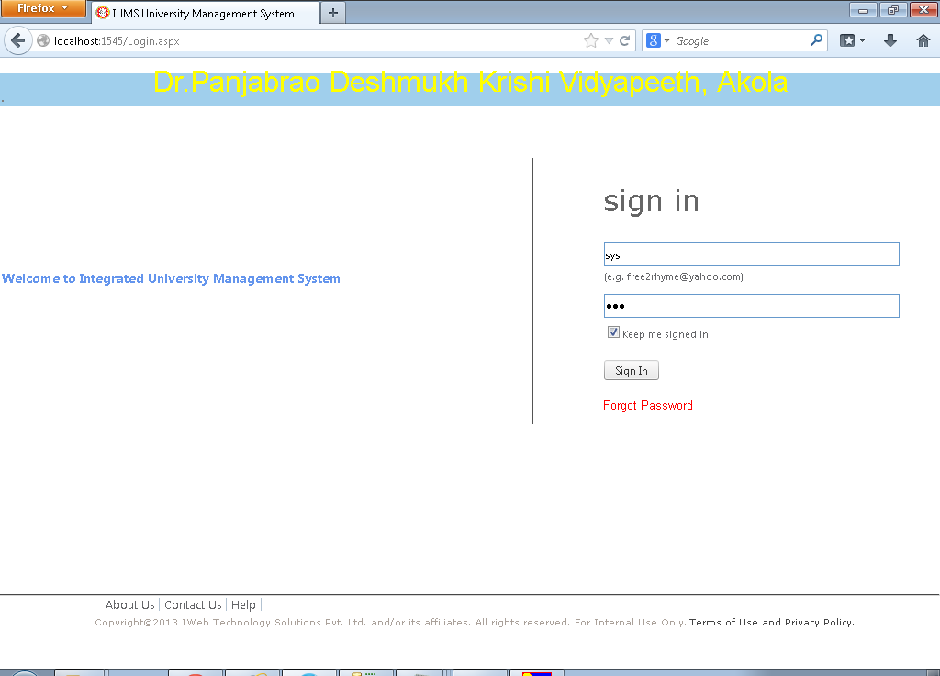

4.2 Maintain Reference Data

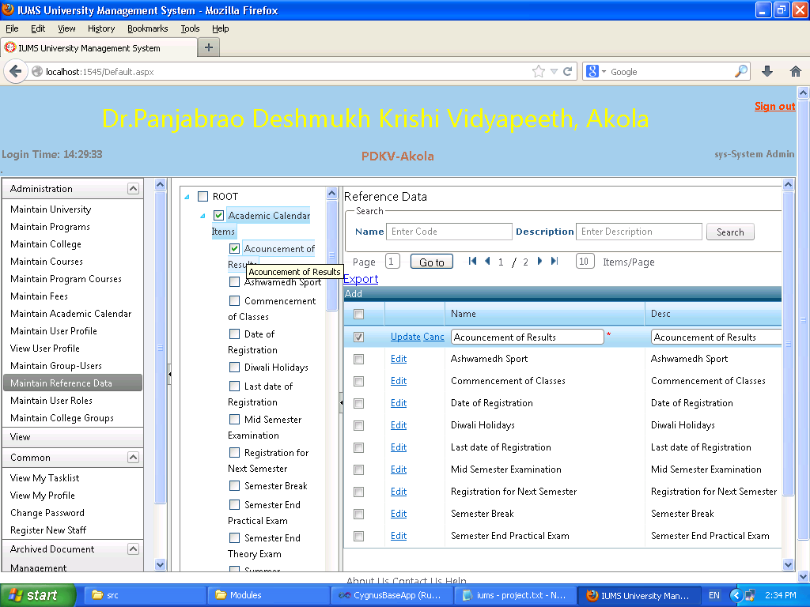

Screen Operation:

Enter Name or Description of the reference data to search. Click on Search button. The list of reference data matching with the given criteria will be displayed in the result grid. Or Click on any of the check box nodes in the Tree panel on the left, the child nodes of the selected node will be displayed in the Result grid. Click on the Edit link in the result grid to see the details of the reference data.

Field Details

|  |  |  |  |
| --- | --- | --- | --- |
| **Field Name** | **Description** | **Mandatory/Optional** | **Validation** |
| Name | Enter name of the reference data | Optional | Alphanumeric |
| Description | Enter description of the reference data | Optional | Alphanumeric |
| Search Button | Click on the search button to display the records matching with the given criteria |  | Click only |

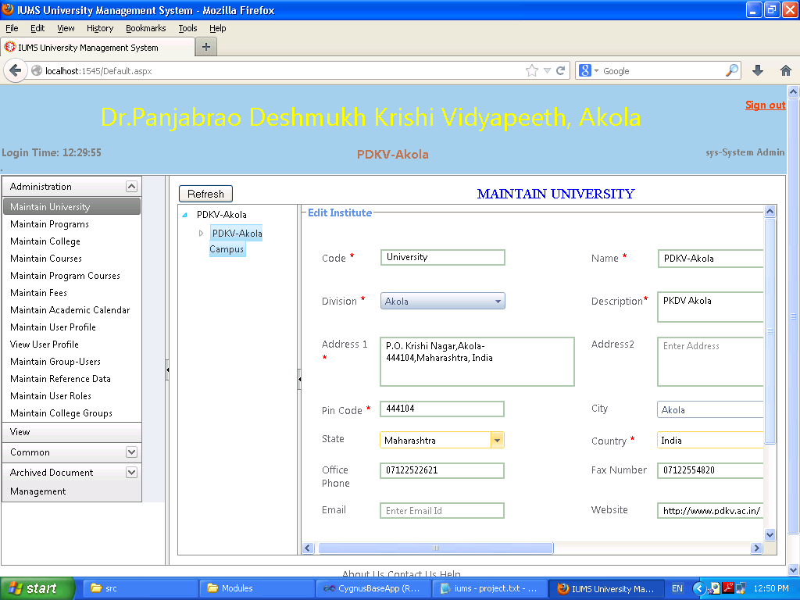4.3 Maintain University

Screen Operation: Click on the node PDKV-Akola Campus in the Tree Panel on the left.

The field details on the right panel will be displayed. You can change any of the fields if necessary and click on Save button to save the changes.

Field Details

|  |  |  |  |
| --- | --- | --- | --- |
| **Field Name** | **Description** | **Mandatory/Optional** | **Validation** |
| Code | Enter a short code used for the university | Mandatory | Alphanumeric |
| Name | Enter name of the university | Mandatory | Alphanumeric |
| Division | Not applicable for University |  |  |
| Description | Enter description of the university |  | Alphanumeric |
| Address 1 | Enter first line of address |  | Alphanumeric |
| Address 2 | Enter second line of address |  | Alphanumeric |
| Pin code | Enter pin code |  | Alphanumeric |
| City | Enter city |  | Alphanumeric |
| State | Select state from the dropdown |  | Select only |
| Country | Select country from dropdown |  | Select only |
| Office Phone | Enter office phone number |  | Numeric |
| Fax Number | Enter fax number |  | Numeric |
| Email | Enter email Id |  | valid email id |
| Website | Enter website address |  | Valid web address |

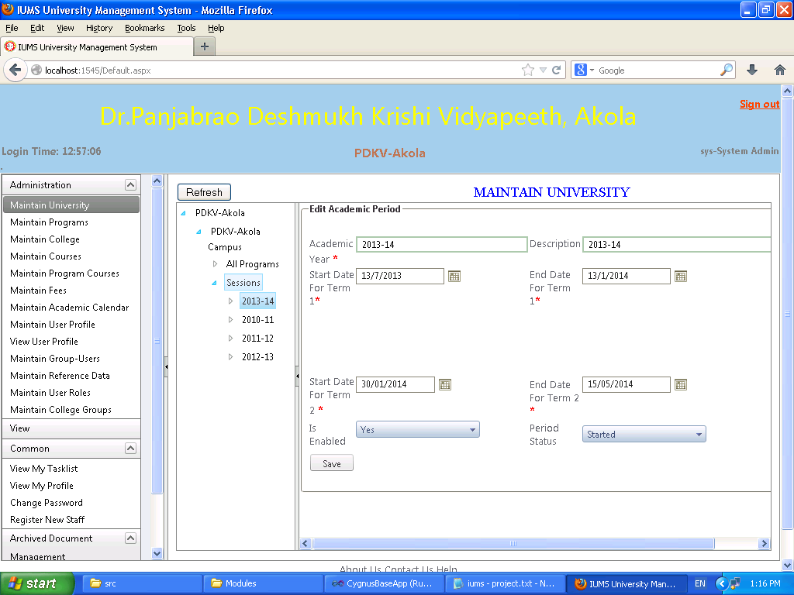4.4 Maintain Academic Year

Screen Operation: Expand the tree in the left panel until you see Sessions. Already created records of academic year will be displayed under the Sessions node. Click on a year to display the details of that academic year in the Right Panel. You can edit the values in the Right Panel. To add a new academic year, Right click on the Sessions node and select Add Academic Year. Input all the mandatory values. Click the Save button to save the new or edited record.

Field Details

|  |  |  |  |
| --- | --- | --- | --- |
| **Field Name** | **Description** | **Mandatory/Optional** | **Validation** |
| Academic Year | Enter the name of the academic year | Mandatory | Alphanumeric |
| Description | Enter description of academic year | Mandatory | Alphanumeric |
| Start Date for Term 1 | Select start date of 1st term of academic year | Mandatory | Date |
| End Date for Term 1 | Select end date of 1st term of academic year | Mandatory | Alphanumeric |
| Start Date for Term 2 | Select start date of 2nd term of academic year | Mandatory | Alphanumeric |
| End Date for Term 2 | Select end date of 2nd term of academic year | Mandatory | Alphanumeric |
| Is Enabled | Select True or False from dropdown | Mandatory | Select only |
| Period Status | Select whether the year has Not Started, Started or Ended from dropdown | Mandatory | Select only |

4.5 Maintain Programs

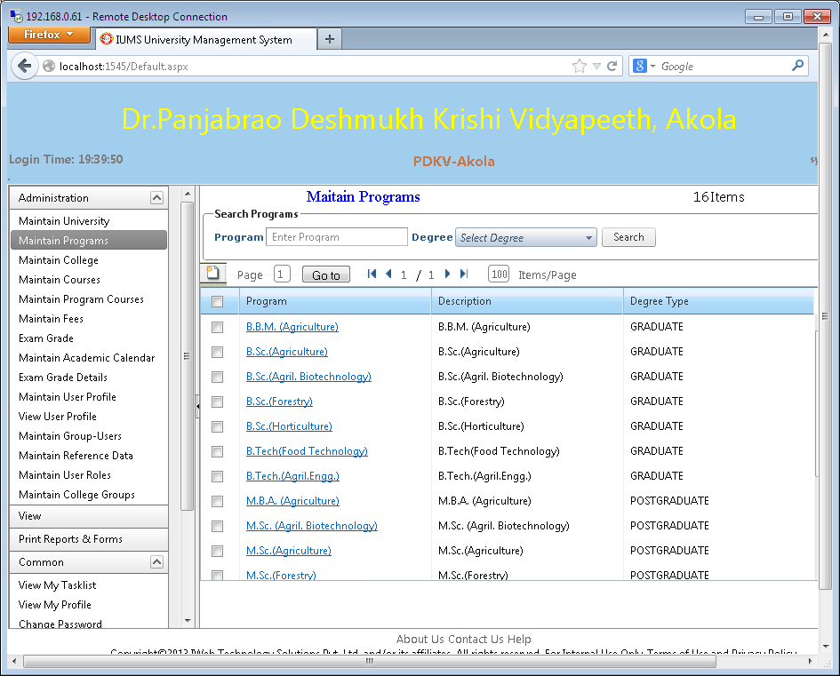

Screen Operation: This screen shows the search & display functionality. Enter the program name to search. Click on the Search button. This list of program names matching with the input letters will be displayed. Or select the Degree type (Graduate, Post Graduate etc) from dropdown and click Search. All the programs of the selected degree type will be displayed. Click on the New icon to add a program in the system. Click on the Hyperlink in the result grid to edit the details of the program.

4.6 Add/Edit Program

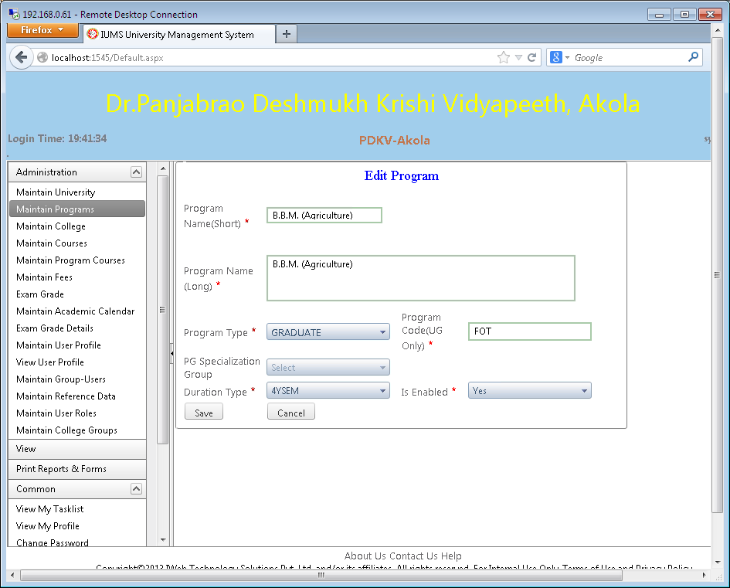

Screen Operation: Enter data in all the mandatory fields. Click the Save button. A message “Data saved successfully” will be displayed. Click on Cancel button to return without saving the changes.

Field Details

|  |  |  |  |
| --- | --- | --- | --- |
| **Field Name** | **Description** | **Mandatory/Optional** | **Validation** |
| Program Name (Short) | Enter short name of the program | Mandatory | Alphanumeric |
| Program Name (Long) | Enter long name of the program | Mandatory | Alphanumeric |
| Program Type | Select program type from dropdown | Mandatory | Select only |
| Program Code (UG only) | Enter program code used for generating Student ID no. | Mandatory | Alphanumeric |
| PG Specialization Group | Select PG Specialization type (Discipline) of the program for PG | Mandatory for PG only | Select only |
| Duration Type | Select duration years and type of the program | Mandatory | Select only |
| Is Enabled | Select Yes/No from dropdown | Mandatory | Select only |

4.8 Maintain Courses

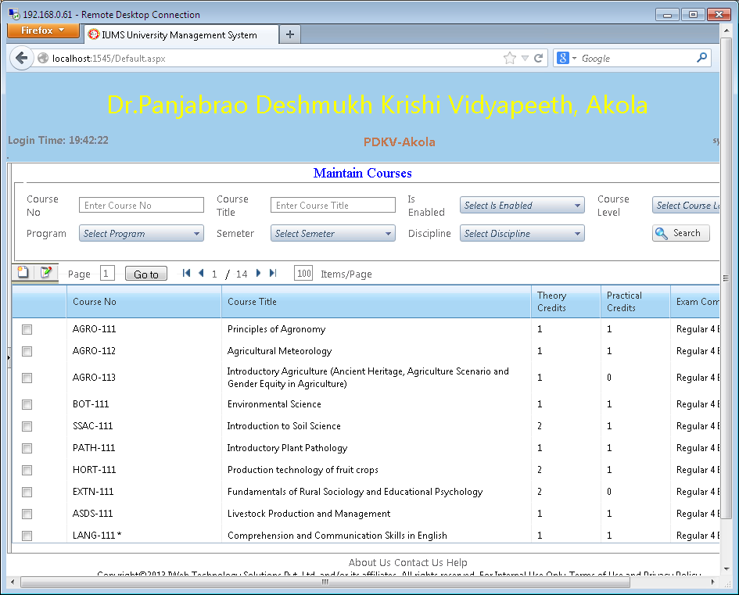

Screen Operation: This screen shows the search & display functionality. Enter the fields on which you want to search. These can be Course No., Course Title, Is Enabled, Course Level (UG or PG) , Program, Semester, or Discipline. Click on the Search button. This list of courses names matching with the input letters will be displayed. Click on the New icon to add a program in the system. Select a course by checking the checkbox in the result grid and click on the Edit icon just above the result grid to edit the details of the course.

4.9 Add/Edit Course

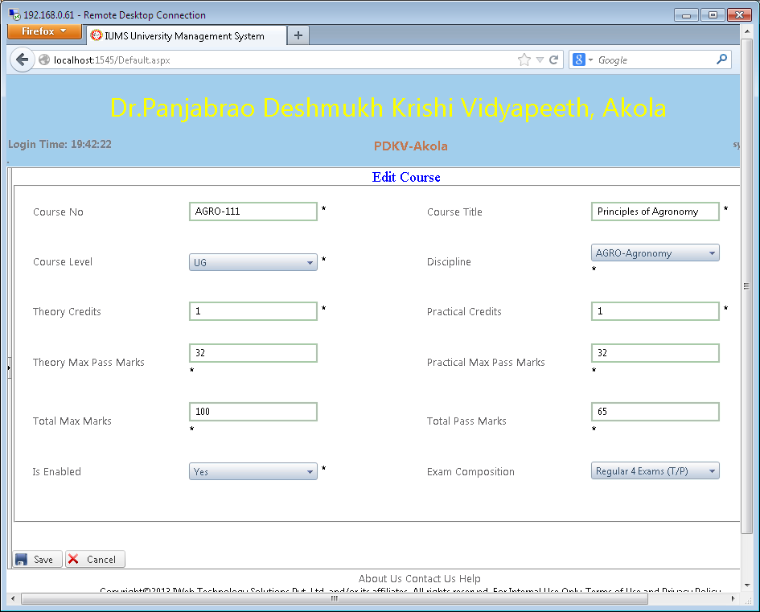

Screen Operation: Enter data in all the mandatory fields. Click the Save button. A message “Data saved successfully” will be displayed. Click on Cancel button to return without saving the changes.

Field Details

|  |  |  |  |
| --- | --- | --- | --- |
| **Field Name** | **Description** | **Mandatory/Optional** | **Validation** |
| Course No. | Enter course No. | Mandatory | Alphanumeric |
| Course Title | Enter course title | Mandatory | Alphanumeric |
| Course Level | Select course level from dropdown | Mandatory | Select only |
| Discipline | Select discipline from dropdown (Only for PG) | Mandatory for PG | Select only |
| Theory Credits | Enter theory credits | Mandatory | Numeric |
| Practical Credits | Enter practical credits | Mandatory | Numeric |
| Theory Max pass marks | marks necessary to pass in theory will be computed and displayed | No entry allowed | N/A |
| Practical Max Pass marks | marks necessary to pass in practical will be computed and displayed | No entry allowed | N/A |
| Total Max marks | total marks will be computed and displayed | No entry allowed | N/A |
| Total pass marks | Total pass marks will be computed and displayed | No entry allowed | N/A |
| Is Enabled | Select Yes/No from dropdown | Mandatory | Select only |
| Exam Composition | Select type of exam composition from dropdown | Mandatory | Select only |

4.10 Maintain Program Courses

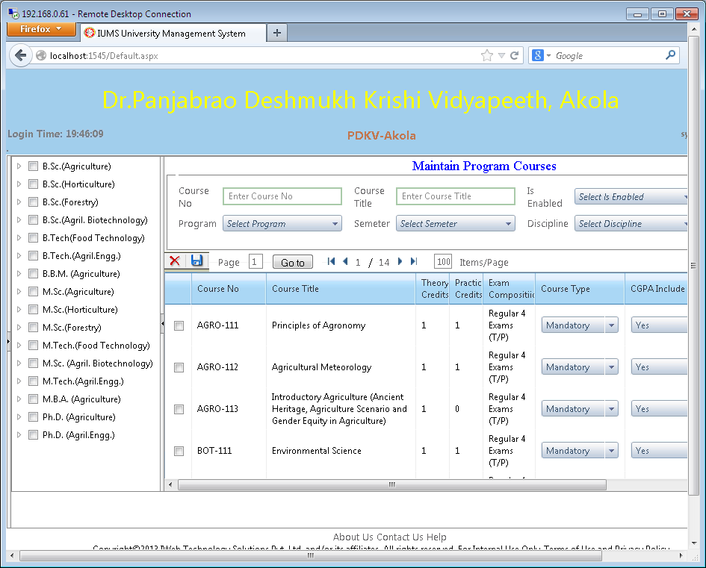

Screen Operation:

To view which courses are allocated to which program: Select Program/Semester/Discipline from the drop down in the search panel. Click on the Search button. Courses already allocated to the program will be displayed in the result grid.

To allocate a course to a program: Search for the desired courses by entering the course no. or course title and get the list of courses in the Result grid. Then select the course by checking the checkbox. Select Course Type , CGPA Include from dropdowns. Expand the program node in the Program Tree in the left pane. Select the semester under the program in which the selected course will be offered by checking the checkbox of the program. Then click on the Save icon.

To remove a course from a program: Click on the Program name in the tree on the left pane. The list of courses already allocated to this program will be displayed. Select the course by checking the checkbox. Click on the Delete button.

4.11 Maintain College

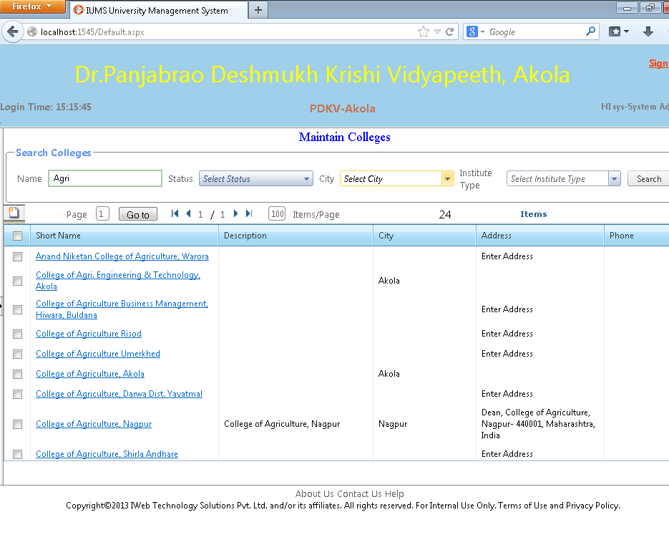Screen Operation: To search for list of colleges, enter starting letters of the college name, or select the city or institute type from the dropdown and click Search button. List of colleges will be displayed in the Result grid. Click on the hyperlink of college name to edit the details of the college. Click on the New icon to add a new college.

4.12 Maintain College (Edit Details)

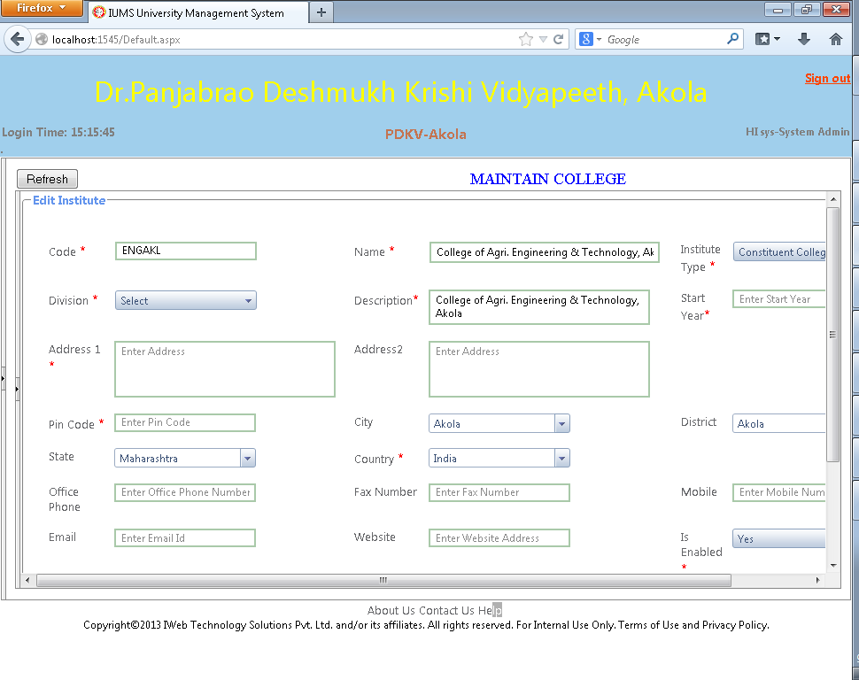

Screen Operation: Enter the mandatory fields. Enter optional fields if necessary. Click the Save button. The message “Data saved successfully” will be displayed.

Field Details

|  |  |  |  |
| --- | --- | --- | --- |
| **Field Name** | **Description** | **Mandatory/Optional** | **Validation** |
| Code | Enter code for college | Mandatory | Alphanumeric |
| Name | Enter name of college | Mandatory | Alphanumeric |
| Institute Type | Select institute type from dropdown | Mandatory | Select only |
| Division | Select division (for CAP center) from dropdown | Mandatory | Select only |
| Description | Enter description of college | Mandatory | Alphanumeric |
| Start Year | Enter start year | Mandatory | Numeric |
| Address 1 | Enter first line of address | Mandatory | Alphanumeric |
| Address 2 | Enter second line of address | Optional | Alphanumeric |
| Pincode | Enter pin code | Mandatory | Numeric |
| City | Enter city | Optional | Alphanumeric |
| District | Select district from dropdown | Optional | Select only |
| State | Select state from dropdown | Optional | Select only |
| Country | Select country from dropdown | Mandatory | Select only |
| Office Phone | Enter office phone no. | Optional | Numeric |
| Fax Number | Enter fax number | Optional | Numeric |
| Mobile | Enter mobile no. | Optional | Numeric |
| Email | Enter email id | Optional | Valid email id |
| Website | Enter website address | Optional | Valid website address |
| Is Enabled | Select Yes/No from dropdown | Mandatory | Select only |

4.13 Maintain College (show Program)

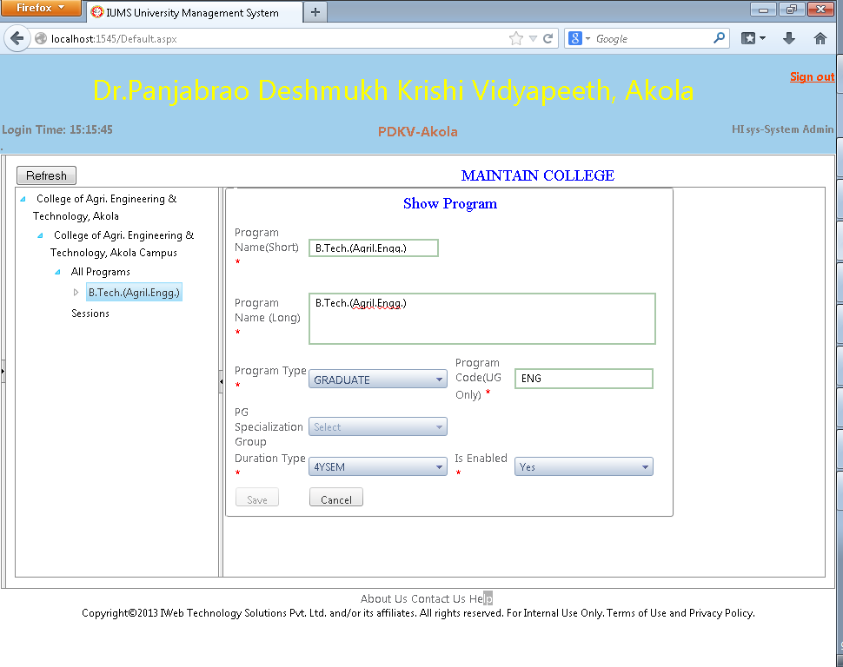

Screen Operation: This screen shows the programs offered by the college. In the Tree in the left pane, expand the Campus node and expand the All Programs node under it. The programs offered by this college campus will be displayed. Click on the name of the program. The details of the program will be displayed in the right pane. Save button is disabled because this screen is not for editing any details.

4.14 Maintain Fees

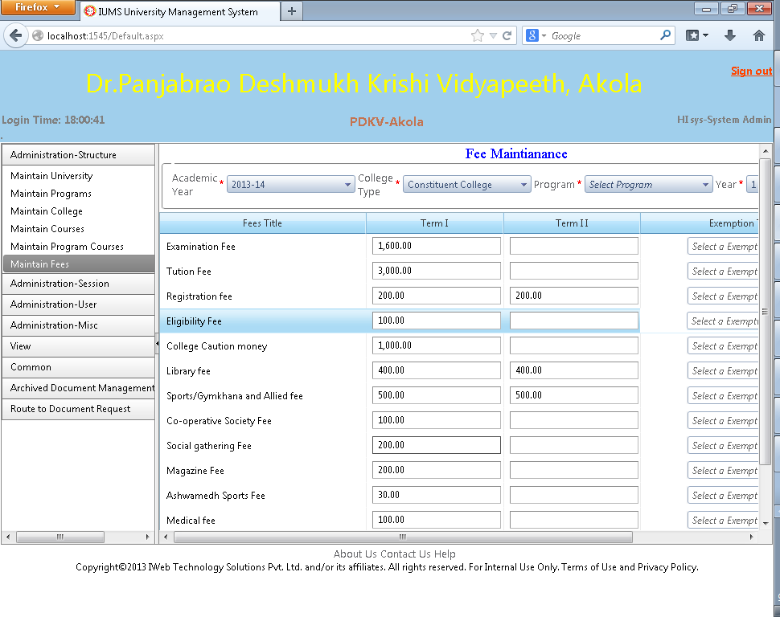

Screen Operation: This screen is used to maintain fees for each academic year for every type of college. Once the fee is setup, all colleges of the selected type (e.g. constituent colleges) will have the same fee structure. Private colleges can create a different fee structure of their own using this option.

Select Academic Year, College Type, Program and Semester from the dropdowns in the top Search panel. Click Search button. If the fee is already setup for this combination, it will be displayed. Otherwise blank textboxes will be shown for all the types of fees. Edit or enter the applicable fee in the textbox against each type of fee. Click the Save button. A message “Data saved successfully” will be displayed.

4.15 Maintain College Group

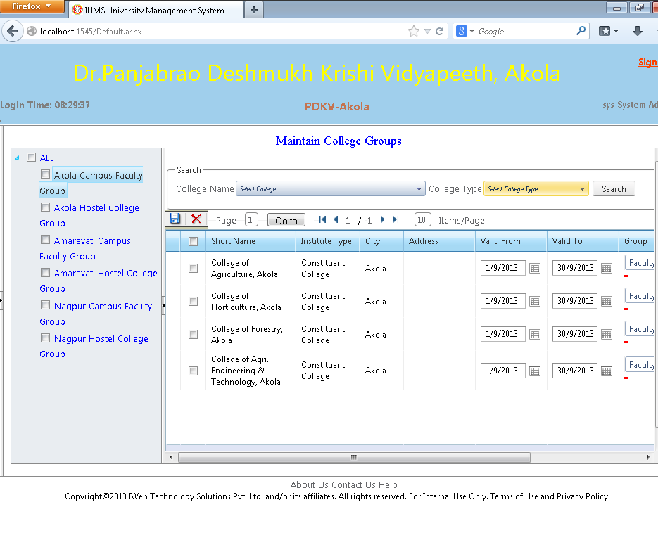

Screen Operation: A group of colleges can be created for sharing the faculty (course teachers) among colleges in the same group or sharing the Hostel facility for students among the college group.

The tree on the left pane displays the possible groups. Click on the Group Name in the tree will display the member colleges of that group in the Right pane.

To add a college to a group: Enter college name or select College from dropdown. Click the Search button to display a list of colleges in the result grid. Select a college in the grid by checking the checkbox against it. Then check the checkbox of the College Group in the tree. Clicking on Add icon will add the college in the selected group.

To remove a college from a group: Click on the Group Name in the tree will display the member colleges of that group in the Right pane. Select a college by checking the checkbox against it. Click on the Delete icon.

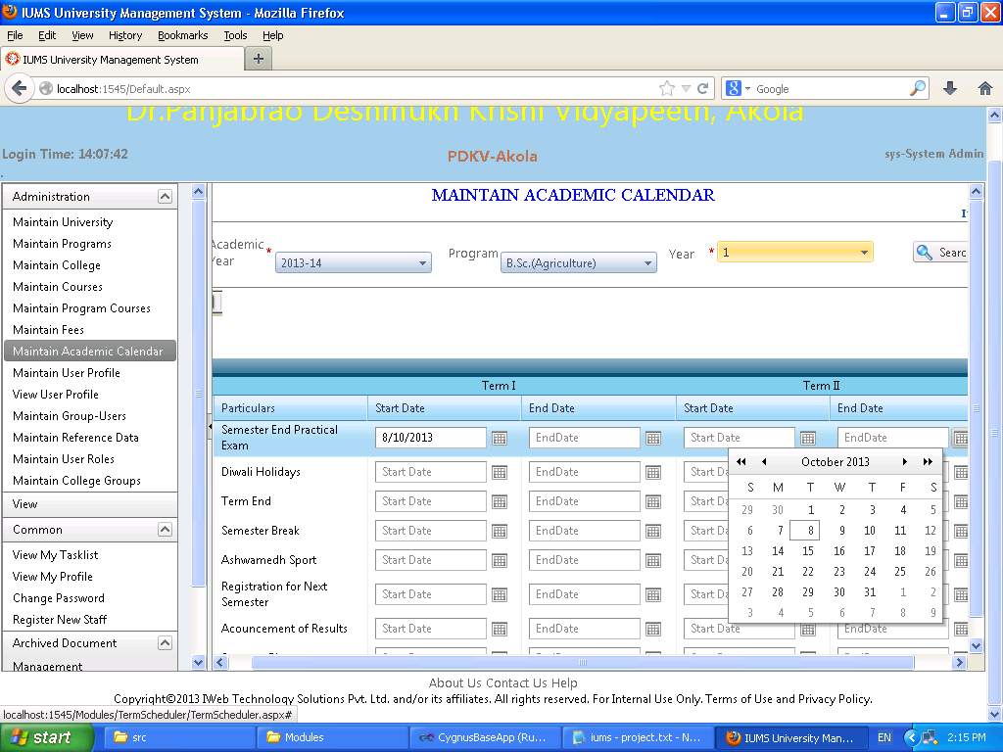4.16 Maintain Academic Calendar

Screen Operation: Select Academic year, Program and Year from dropdown. Click Search button.

If the academic calendar has been already set, various academic activities and their start/end dates will be displayed for term 1 & term 2. Otherwise it will display blank for all activities. Select the dates from the calendar controls in front of each activity and finally click Save. A message “Data saved successfully” will be displayed.

4.17 Maintain Group Users

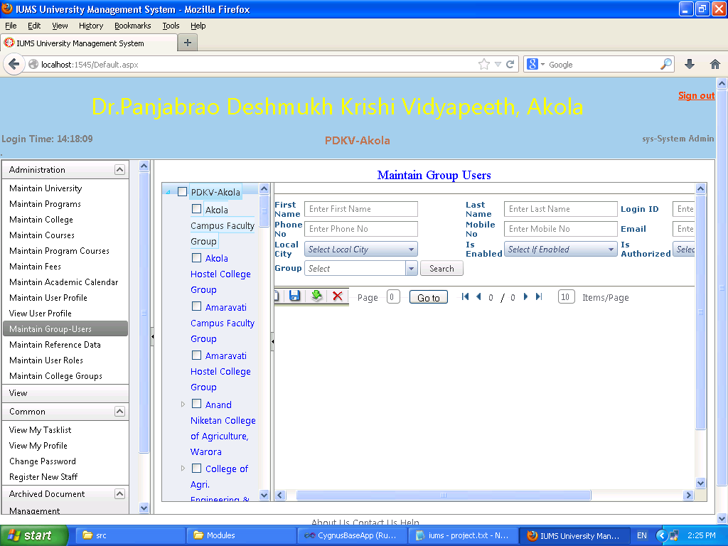

Screen Operation:

To add a user to a group: Search the desired user by entering any one like First Name, Last Name, Login Id, email, mobile no. etc. The matching users will be displayed in the Result grid. Select the user by checking the checkbox against it. Select the desired group by checking the checkbox against it. Click the Save button.

To display users in a group: Click on the group name in the tree in the left Pane. The members of the group will be displayed in the right pane.

To remove a user from a group: Select the user from the right pane by checking the checkbox against it. Click the Delete button.